Functions can be dependent on other functions. As well as their domain and range being related, their rates of change (derivatives) are related. This section shows what related rates are and how to construct related rates.

# Related Rates

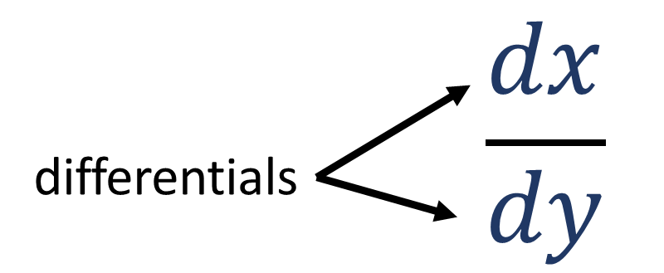Differential (*object*) – a measure of change (difference) in a variable. Examples: $dx$, $dy$, $dV$. See Figure 1.

Figure

If two rates of change are known (they may be derived from formulas), and they share one differential, another rate of change can be identified using algebraic rules. “Related rates” of change study theses relations.

Related rates may exist in the form of the equation below, for some variables $A$, $B$, and $C$.

$$\frac{dA}{dB}=\frac{dA}{dC}⋅\frac{dC}{dB}$$

Canceling out the $dC$ differential on the middle and right fractions leaves the left differential fraction.

# Strategy for Solving

The textbook recommends these strategies[1] for solving related rate word problems.

1. Read the problem carefully.
2. Draw a diagram if possible.
3. Introduce notation. Assign symbols to all quantities that are functions of time.
4. Express the given information and the required rates of change in derivatives.
5. Write an equation that relates the various quantities of the problem. If necessary, use the geometry of the situation to eliminate one of the variables by substitution.
6. Use the Chain Rule to differentiate both sides of the equation with respect to $t$.
7. Substitute the given information into the resulting equation and solve for the unknown rate.

The following examples illustrate this process.

[See 2-7 Exercises]

# What Did You Learn?

* What are related rates?
* How do you relate two derivatives that share one differential?
* Why are related rates true to reality?

1. Stewart, J. (2013). Essential Calculus - Early Transcendentals. In J. Stewart, *Essential Calculus - Early Transcendentals* (p. 131). Belmont, CA: BROOKS/COLE CENGAGE Learning.